Operation Instruction for 450nm /1W laser
Note1:
The laser only can be operated after the case temperature of the laser system return to the room temperature to avoid the damage of the big temperature range.

Note2：
Start Up the laser module: First connect the laser module power, and then turn on the power button.
Shut down the laser module: First turn off the power button, and then unlink the laser module power.

- Product features

  - Place the laser head which has the same serial number with the power supply on a stable and better heat-conducting plate, such as metal plate.
Note: The heat-sink at the top of laser-head is air duct.
- The air duct should not be blocked, and make sure there is nothing placed within 0.05m-0.1m.
- If the laser system needs to be installed into equipment, please make sure the airflow clear.
- If a cooling fan is needed in the equipment, please make sure the wind direction is the same as right figure.
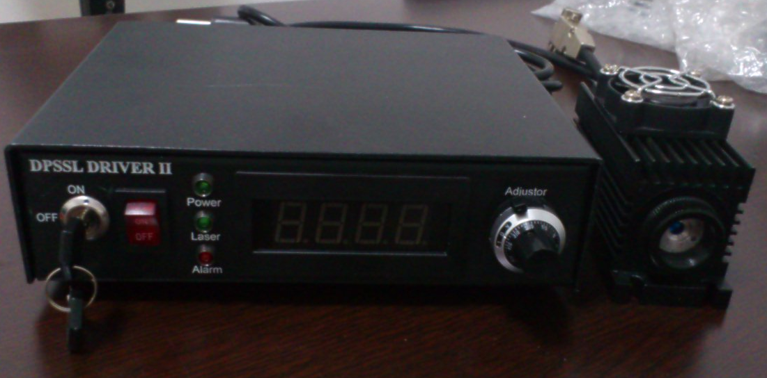

Front Panel of the power supply：
1. Current adjustor
Current will rise when rotating the adjustor clockwise
2. Current Meter
It shows the current as factory default
3. LED for normal working
Green LED on when the driver is normal working
4. LED for power
Turn on the key switch at “ON” state. The power supply starts to work after about 2 seconds delay. This LED is on
5. LED for over-temperature
Red LED on when the power driver is auto-shutdown because of over-temperature or some other reasons.
6. Power On-Off
7. Key switch
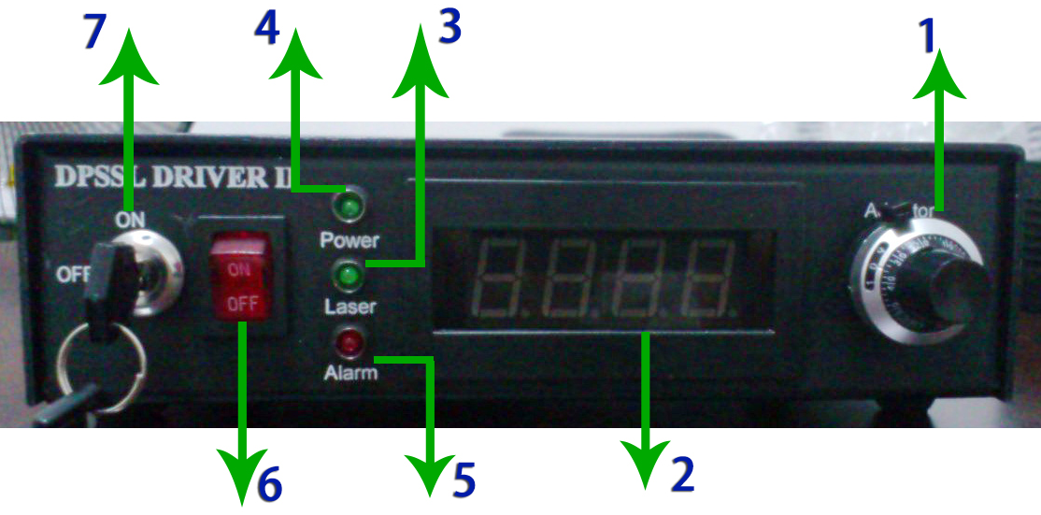

Rear Panel:
1. Power port
To connect power driver with 220V or 110V source
2. Signal input connector
To connect power driver with 0~5V TTL or Analog modulation
TTL: for 5V 0~30KHz
Analog: for 5V 0~20KHz analogue modulation
3. Output pin port
To connect power driver with laser head by 9-pin cord
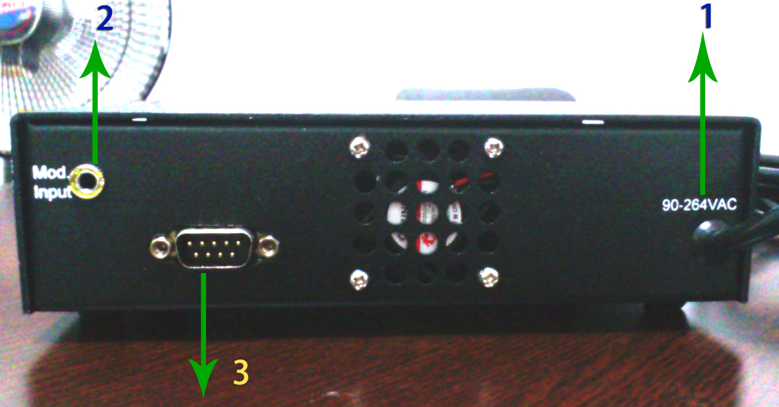
- Operation

  - Attach the laser head to the connector of power supply firmly. Please make sure to fasten the locking ring on the connector.
  - Remove the label at aperture.
  - Turn on the key switch at “ON” state and the main power of the power supply. The green LED - “Power” is on.
  - The laser start to work after 2 seconds, the green LED-“Laser” is on. The warming up time is about 15minutes
  - Only for unexpected accident occurs, the red LED-“Error” will be on. That means the laser system works in abnormal state. Please switch off the mains power. Please reset the mains power and key switch after a few minutes, then to restart the laser system again.
  - TTL modulation are optional. As for the TTL instruction.
Note: ForTTL function, you need to input5 VDC input voltage.
  - Closing the laser system: switch off the mains power of the power supply and key switch.

- Warranty

  - The warranty is one year from the shipping date.
  - This warranty will not apply to those products which have been.
    - Repaired or altered other than in accordance with the terms of this Agreement.
    - Abused, misused, improper handling in use, or storage, or used in an unauthorized or improper manner or without following written procedures supplied by manufacturer.
    - Original identification markings or labels have been removed, defaced or altered.
    - Any other claims not arising directly from material defects in material or workmanship.

- Laser safety

  - All lasers and laser light show systems have intrinsic dangers - even laser pointers! Observation of basic laser safety rules and the specific safety regulations of the jurisdiction in which you operate are essential.
  - Safety with high powered lasers is a critical issue that cannot be overlooked. Despite their brilliant beams and ability to burn, high power laser pointers and portable lasers are only a danger to your eyes. The danger that lasers represent to your eyes though is very serious. The visual receptors in your eyes are part of your central nervous system which means if your eyes are damaged, they do not heal or recover.
  - As far as power output, laser pointers and portable lasers do not release that much power. Especially not when compared to a normal 75W or 100W light globe. What makes the light from lasers so dangerous is that it has two unique properties.
    - Coherent and focused. The energy is focused on a very small area similar to the way a magnifying glass focuses the sun.
    - Collimated. The light does not spread out from a laser; it stays in a focused narrow beam that makes lasers almost as dangerous at a distance as close up.
This not to say you should be afraid of lasers or avoid using them. What you should do how ever is to treat lasers with respect, be aware of their dangers and follow some basic guidelines to ensure your safety.

